BDB AND BQUERY DOCUMENTATION.

Baraza employs postgreSQL as the main database system. connection to the database is made using the postgreSQL database drivers.
Making use of methods defined in the BElement class, the BDB class helps in database connection and initialize the database and web output. It also defines methods that will be used in the BQuery class, which is still used to interact with the database. The diagram below summarises BDB's functionality.

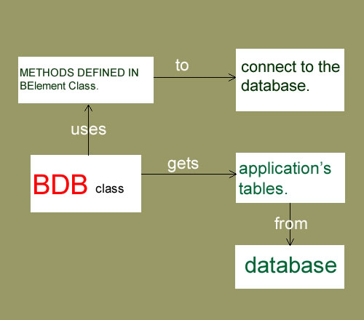

The BQuery class contains methods to navigate through the resultset, update, delete or add data to the database using the sql query language. It communicates with the BDB class, which retrieves the tables in the database.
For a particular table, it retrieves the column names ,which will be used to define the user interface, the labels being the column names. The user interface defined is usually a master-detail view, which provides a rich user experience.

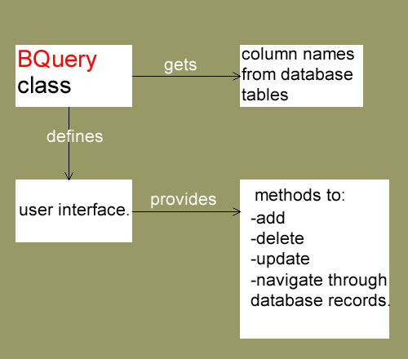

Baraza removes the need for one to explicitly code for the applications user interface and the inner details involving the database such as navigating through a resultset, filtering data.

